DBH modelling problem

DBH modelling approaches start with a gaussian glm for Tree.growth~all parameters, then learn from this model and find better models. Currently, we’ve tried glm on removing Tree.growth outliers, log(Tree.growth), boxcox(Tree.growth), mixed-effect models, and seperate glm models for not-large trees and large trees. For all these models, there are some problems which block the “find better model” progress:

**Problem**

1. Small R^2 value (<0.5 for all models, one exception with R^2=0.5183584)
2. Response variable being not normal and having inconsistent variance (heteroscedastic) seems not the problem why glm doesn’t fit well. Don’t know why glm doesn’t fit well.

-> evidence: log() and boxcox() have similar result; glm2.1, glm2.2 have smaller R^2 value than glm2.0

1. Even after boxcox() transformation, response variable still cannot have normal distribution or consistent variance. Is it necessary to have transformation on Tree.growth? Maybe there’s other models which can model non normally distributed heteroscedastic data?

-> evidence: shapiro test and Levene’s test

1. glm cannot capture enough range, range(fitted values for each group) < range(actual value)

-> evidence: fitted vs actual plots

1. glm cannot explain Tree.gowth in large trees. Currently mixed effect model has a better result than glm. Don’t know what model can fit Tree.gowth in large trees better.

-> evidence: fitted vs actual plots; mixed4.0

1. original data is scattered and has many overlap Tree.growth values among groups.

-> evidence: scatter plots of original data

**Current modelling progress**

**start with gaussian glm for original data Tree.growth**

# best model derived from Tree.growth~DBH.year.0*Large*Treatment  
glm1.0 = glm(Tree.growth~DBH.year.0+Treatment+Large+DBH.year.0:Large+Treatment:Large, data = DBHdata)

tss = sum((DBHdata$Tree.growth-mean(DBHdata$Tree.growth))^2) #TSS  
rss = sum((DBHdata$Tree.growth-fitted(glm1.0))^2) #RSS  
(tss-rss)/tss #R^2

## [1] 0.2847149

par(mfrow=c(2,2))  
plot(glm1.0)

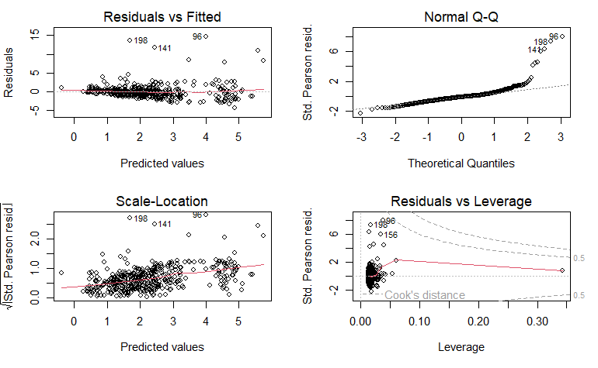

glm1.0 doesn’t fit well.

Evidence: 1. R^2 = 0.2847149

1. In Residual vs Fitted plot, residuals are quite large and seems to have a cone shape.
2. In Normal Q-Q plot, the tail is very far from normal.

Why? 1. There are large outliers in Tree.growth.

1. Tree.growth doesn’t follow a normal distribution -> evidence: shapiro test
2. Variance of Tree.growth is not the same for each group (not-large vs large, Control vs T1 vs T2) -> evidence: Levene’s test

Solution: Remove outliers.

**gaussian glm for outliers removed Tree.growth**

plot(DBHdata$Tree.growth~DBHdata$DBH.year.0, type = "p", col = DBHdata$Treatment); plot(DBHdata$Tree.growth~DBHdata$DBH.year.0, type = "p", col = DBHdata$Large)

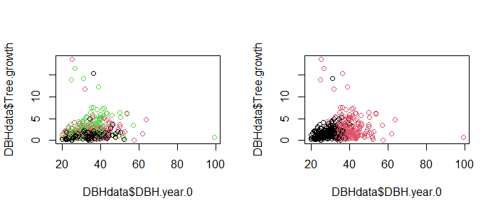

DBHremove = DBHdata[DBHdata$Tree.growth < 10 & DBHdata$DBH.year.0 < 80, ] # remove 8 rows

# same formula as glm1.0  
glm2.0 = glm(Tree.growth~DBH.year.0+Treatment+Large+DBH.year.0:Large+Treatment:Large, data = DBHremove)

tss = sum((DBHremove$Tree.growth-mean(DBHremove$Tree.growth))^2) #TSS  
rss = sum((DBHremove$Tree.growth-fitted(glm2.0))^2) #RSS  
(tss-rss)/tss #R^2

## [1] 0.4149165

par(mfrow=c(2,2)); plot(glm2.0)

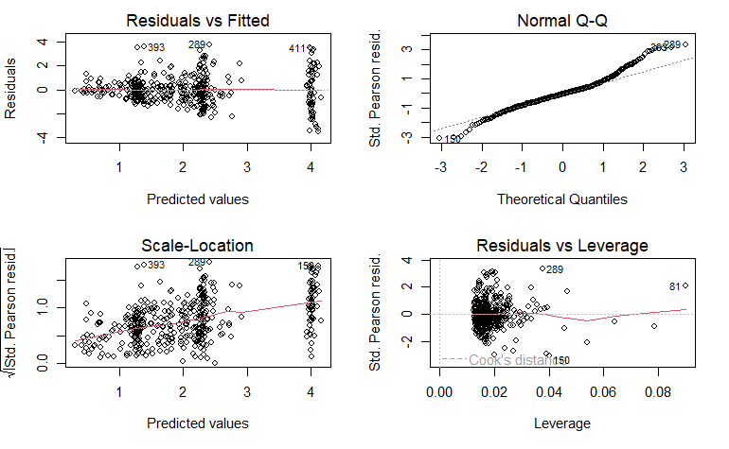

par(mfrow=c(1,2))  
plot(DBHremove$Tree.growth, fitted(glm2.0), type = "p", col = DBHremove$Treatment, main = "Fitted vs Actual (color Treatment)")  
legend("bottomright", legend = c("Control", "T1", "T2"), fill = c("black", "red", "green"))  
abline(0, 1)  
plot(DBHremove$Tree.growth, fitted(glm2.0), type = "p", col = DBHremove$Large, main = "Fitted vs Actual (color Large)")  
legend("bottomright", legend = c("not-large", "large"), fill = c("black", "red"))  
abline(0, 1)

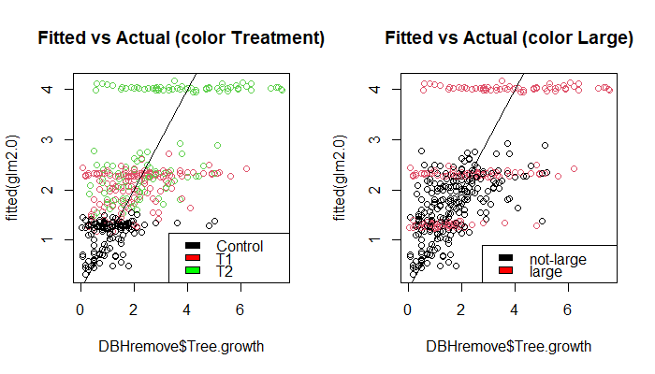

Removing outliers have improved the model. glm2.0 is better than glm1.0, but still not a good enough fit.

Evidence: 1. R^2 = 0.4149165

1. In Normal Q-Q plot, heavy tails far from normal.
2. In Residual vs Fitted plot, residuals are still quite large and have a very significant cone shape and group pattern.
3. In Fitted vs Actual(color Treatment) plot, there are three horizontal lines (one in each color). If compared to Fitted vs Actual(color Large) plot, it’s clear that these three lines are caused by large trees. These three horizontal lines also match the group pattern in Residual vs Fitted plot. This means glm2.0 cannot explain large trees.

Why? 1. Tree.growth doesn’t follow a normal distribution. -> evidence: shapiro test

1. Variance of Tree.growth is not the same for each group (not-large vs large, Control vs T1 vs T2) -> evidence: Levene’s test

Solution: log(), boxcox(), seperatly model not-large and large.

**gaussian glm for log(DBHremove)**

DBHremove$Tree.growth.log = log(DBHremove$Tree.growth)  
  
# same formula as glm1.0  
glm2.1 = glm(Tree.growth.log~DBH.year.0+Treatment+Large+DBH.year.0:Large+Treatment:Large, data = DBHremove)

tss = sum((DBHremove$Tree.growth.log-mean(DBHremove$Tree.growth.log))^2) #TSS  
rss = sum((DBHremove$Tree.growth.log-fitted(glm2.1))^2) #RSS  
(tss-rss)/tss #R^2

## [1] 0.3534699

par(mfrow=c(2,2))  
plot(glm2.1)

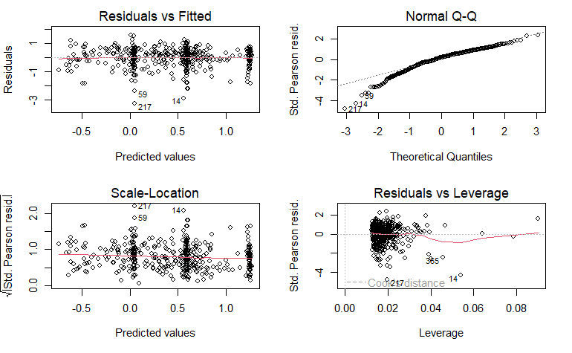

par(mfrow=c(1,2))  
plot(DBHremove$Tree.growth.log, fitted(glm2.1), type = "p", col = DBHremove$Treatment, main = "Fitted vs Actual (color Treatment)")  
legend("topleft", legend = c("Control", "T1", "T2"), fill = c("black", "red", "green"))  
abline(0, 1)  
plot(DBHremove$Tree.growth.log, fitted(glm2.1), type = "p", col = DBHremove$Large, main = "Fitted vs Actual (color Large)")  
legend("topleft", legend = c("not-large", "large"), fill = c("black", "red"))  
abline(0, 1)

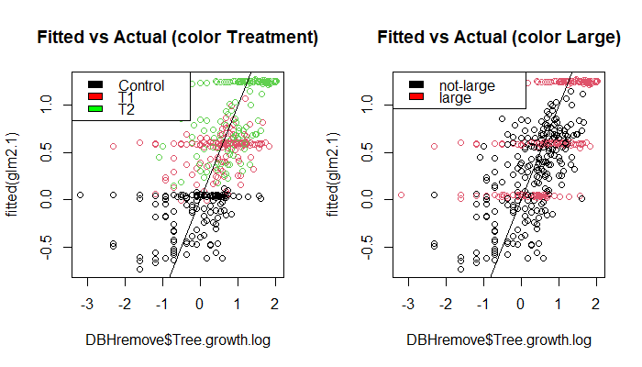

glm2.1 is better in some case but worse in some criteria compared to glm2.0. It’s not a good fit.

Evidence: 1. R^2 = 0.3534699 (< R^2 of glm2.0)

2.In Normal Q-Q plot, one heavy tail far from normal.

3. In Residual vs Fitted plot, residuals are flat and slightly smaller than glm2.0 but still quite large.

4. In Fitted vs Actual plots, there are still the three horizontal lines caused by large trees. This means glm2.1 cannot explain large trees.

Why? Tree.growth doesn’t follow a normal distribution. -> evidence: shapiro test

**gaussian glm for boxcox(DBHremove)**

#library(MASS)  
b = boxcox(DBHremove$Tree.growth~1, lambda = seq(0, 0.5, 0.05))

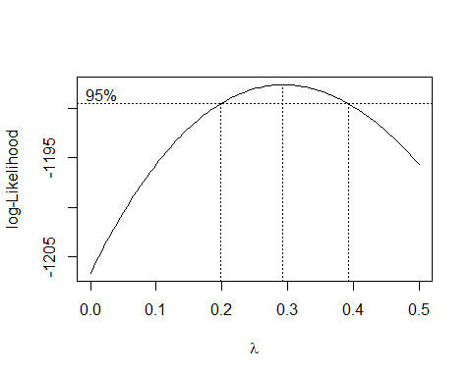

lambda = b$x[which.max(b$y)]  
DBHremove$Tree.growth.boxcox = (DBHremove$Tree.growth^lambda-1)/lambda

glm2.2 = glm(Tree.growth.boxcox~DBH.year.0+Treatment+Large+DBH.year.0:Large+Treatment:Large, data = DBHremove)

tss = sum((DBHremove$Tree.growth.boxcox-mean(DBHremove$Tree.growth.boxcox))^2) #TSS  
rss = sum((DBHremove$Tree.growth.boxcox-fitted(glm2.2))^2) #RSS  
(tss-rss)/tss #R^2

## [1] 0.3907872

par(mfrow=c(2,2)); plot(glm2.2)

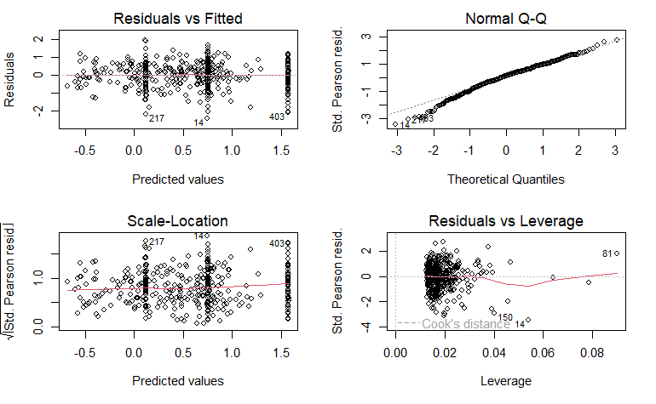

par(mfrow=c(1,2))  
plot(DBHremove$Tree.growth.boxcox, fitted(glm2.2), type = "p", col = DBHremove$Treatment, main = "Fitted vs Actual (color Treatment)")  
legend("topleft", legend = c("Control", "T1", "T2"), fill = c("black", "red", "green"))  
abline(0, 1)  
plot(DBHremove$Tree.growth.boxcox, fitted(glm2.2), type = "p", col = DBHremove$Large, main = "Fitted vs Actual (color Large)")  
legend("topleft", legend = c("not-large", "large"), fill = c("black", "red"))  
abline(0, 1)

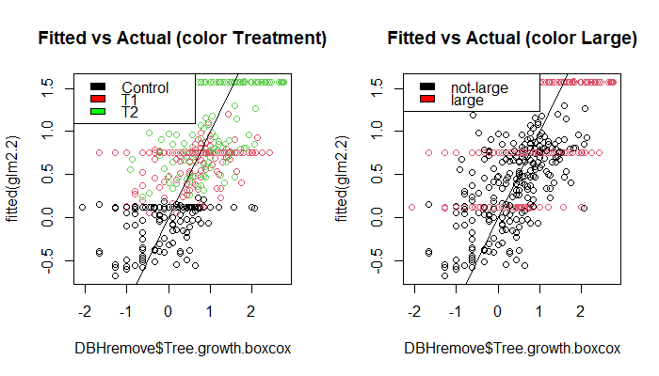

glm2.2 is slightly better than glm2.1, but result is similar to glm2.1. It’s still not a good fit.

Evidence: 1. R^2 = 0.3907872 > glm2.1 R^2.

2.In Normal Q-Q plot, points are not very far away from normal, can be considered as normal.

3. In Residual vs Fitted plot, residuals are smaller and flat.

4. In Fitted vs Actual plots, there are still the three horizontal lines caused by large trees. This means glm2.2 cannot explain large trees.

Why? Variance of Tree.growth is not the same for each group (not-large vs large, Control vs T1 vs T2) -> evidence: Levene’s test

**mixed effect model for DBHremove$Tree.growth**

#library(lme4)  
mixed2.0 = lmer(Tree.growth~DBH.year.0+Treatment+Large+DBH.year.0:Large+Treatment:Large+(-1+DBH.year.0+Treatment+Large+DBH.year.0:Large+Treatment:Large|Plot), data = DBHremove)

## boundary (singular) fit: see help('isSingular')

y.hat2.0 <- fitted(mixed2.0) # Fitted values  
#int.hat2.0 <- ranef(mixed2.0)[[1]][[1]] # Predicted intercepts  
res.hat2.0 <- residuals(mixed2.0) # Estimated residuals  
tss = sum((DBHremove$Tree.growth-mean(DBHremove$Tree.growth))^2) #TSS  
rss = sum((DBHremove$Tree.growth-y.hat2.0)^2) #RSS  
(tss-rss)/tss #R^2

## [1] 0.5183584

#qqnorm(int.hat2.0, main="Random Intercepts"); qqline(int.hat2.0)  
qqnorm(res.hat2.0, main="Residuals"); qqline(res.hat2.0)

plot(y.hat2.0, res.hat2.0, xlab="Fitted Values", ylab="Residuals")  
abline(h=0, lty=2)

plot(DBHremove$Tree.growth, y.hat2.0, col = DBHremove$Treatment)  
abline(0, 1)

plot(DBHremove$Tree.growth, y.hat2.0, col = DBHremove$Large)  
abline(0, 1)

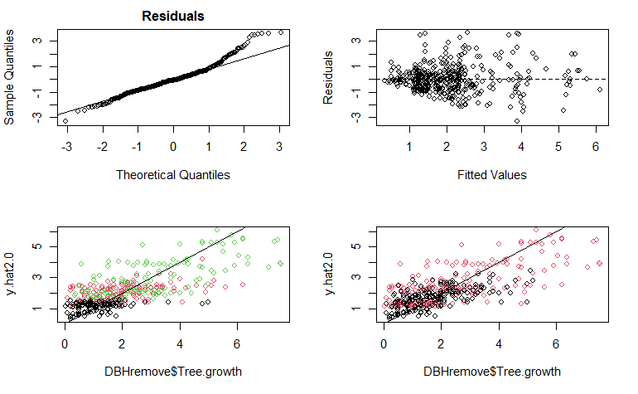

**seperatly model not-large and large**

largerm = DBHremove[DBHremove$Large == "Yes", 1:11]  
nlargerm = DBHremove[DBHremove$Large == "No", 1:11]

plot(largerm$Tree.growth~largerm$DBH.year.0, type = "p", col = largerm$Treatment)

plot(nlargerm$Tree.growth~nlargerm$DBH.year.0, type = "p", col = nlargerm$Treatment)

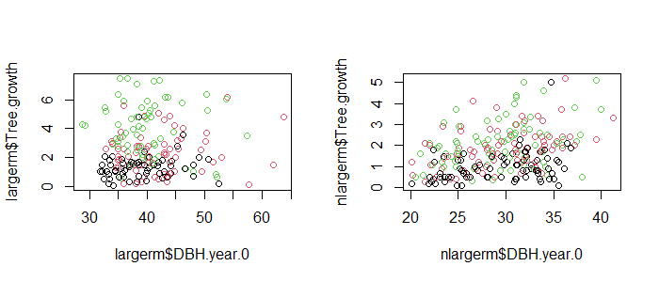

**mixed effect model using largerm**

#library(lme4)  
mixed4.0 = lmer(Tree.growth~DBH.year.0+Treatment+(DBH.year.0+Treatment|Plot), data = largerm)

## boundary (singular) fit: see help('isSingular')

y.hat4.0 <- fitted(mixed4.0) # Fitted values  
int.hat4.0 <- ranef(mixed4.0)[[1]][[1]] # Predicted intercepts  
res.hat4.0 <- residuals(mixed4.0) # Estimated residuals  
tss = sum((largerm$Tree.growth-mean(largerm$Tree.growth))^2) #TSS  
rss = sum((largerm$Tree.growth-y.hat4.0)^2) #RSS  
(tss-rss)/tss #R^2

## [1] 0.4999456

qqnorm(int.hat4.0, main="Random Intercepts"); qqline(int.hat4.0)

qqnorm(res.hat4.0, main="Residuals"); qqline(res.hat4.0)

plot(y.hat4.0, res.hat4.0, xlab="Fitted Values", ylab="Residuals")  
abline(h=0, lty=2)

plot(largerm$Tree.growth, y.hat4.0, col = largerm$Treatment)  
abline(0, 1)

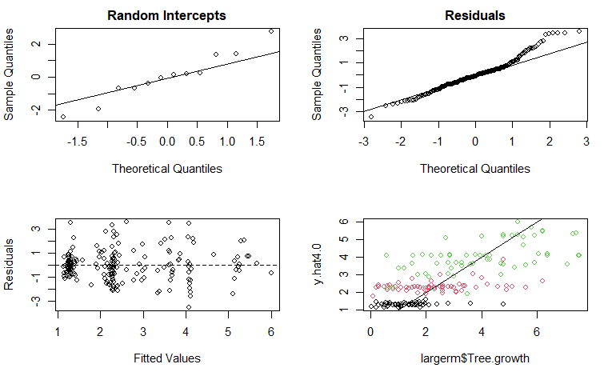

**tests**

shapiro.test(DBHdata$Tree.growth) # not normal

##   
## Shapiro-Wilk normality test  
##   
## data: DBHdata$Tree.growth  
## W = 0.69124, p-value < 2.2e-16

library(car)

## Loading required package: carData

leveneTest(Tree.growth~Large, data = DBHdata) # variance are different between large and not-large groups

## Levene's Test for Homogeneity of Variance (center = median)  
## Df F value Pr(>F)   
## group 1 26.259 4.518e-07 ***  
## 430   
## ---  
## Signif. codes: 0 '***' 0.001 '**' 0.01 '*' 0.05 '.' 0.1 ' ' 1

leveneTest(Tree.growth~Treatment, data = DBHdata) # variance are different across each Treatment group

## Levene's Test for Homogeneity of Variance (center = median)  
## Df F value Pr(>F)   
## group 2 13.445 2.17e-06 ***  
## 429   
## ---  
## Signif. codes: 0 '***' 0.001 '**' 0.01 '*' 0.05 '.' 0.1 ' ' 1

shapiro.test(DBHremove$Tree.growth) # not normal

##   
## Shapiro-Wilk normality test  
##   
## data: DBHremove$Tree.growth  
## W = 0.89365, p-value < 2.2e-16

#library(car)  
leveneTest(Tree.growth~Large, data = DBHremove) # variance are different between large and not-large groups

## Levene's Test for Homogeneity of Variance (center = median)  
## Df F value Pr(>F)   
## group 1 35.929 4.394e-09 ***  
## 422   
## ---  
## Signif. codes: 0 '***' 0.001 '**' 0.01 '*' 0.05 '.' 0.1 ' ' 1

leveneTest(Tree.growth~Treatment, data = DBHremove) # variance are different across each Treatment group

## Levene's Test for Homogeneity of Variance (center = median)  
## Df F value Pr(>F)   
## group 2 33.811 2.413e-14 ***  
## 421   
## ---  
## Signif. codes: 0 '***' 0.001 '**' 0.01 '*' 0.05 '.' 0.1 ' ' 1

shapiro.test(DBHremove$Tree.growth.log) # not normal

##   
## Shapiro-Wilk normality test  
##   
## data: DBHremove$Tree.growth.log  
## W = 0.96584, p-value = 2.232e-08

#library(car)  
leveneTest(Tree.growth.log~Large, data = DBHremove) # variance can be considered as consistent between large and not-large groups

## Levene's Test for Homogeneity of Variance (center = median)  
## Df F value Pr(>F)   
## group 1 2.8423 0.09255 .  
## 422   
## ---  
## Signif. codes: 0 '***' 0.001 '**' 0.01 '*' 0.05 '.' 0.1 ' ' 1

leveneTest(Tree.growth.log~Treatment, data = DBHremove) # variance are consistent across each Treatment group

## Levene's Test for Homogeneity of Variance (center = median)  
## Df F value Pr(>F)  
## group 2 0.8574 0.425  
## 421

shapiro.test(DBHremove$Tree.growth.boxcox) # normal

##   
## Shapiro-Wilk normality test  
##   
## data: DBHremove$Tree.growth.boxcox  
## W = 0.99514, p-value = 0.2063

#library(car)  
leveneTest(Tree.growth.boxcox~Large, data = DBHremove) # variance are different between large and not-large groups

## Levene's Test for Homogeneity of Variance (center = median)  
## Df F value Pr(>F)   
## group 1 11.263 0.0008622 ***  
## 422   
## ---  
## Signif. codes: 0 '***' 0.001 '**' 0.01 '*' 0.05 '.' 0.1 ' ' 1

leveneTest(Tree.growth.boxcox~Treatment, data = DBHremove) # variance can be considered as consistent across each Treatment group

## Levene's Test for Homogeneity of Variance (center = median)  
## Df F value Pr(>F)   
## group 2 2.9614 0.05282 .  
## 421   
## ---  
## Signif. codes: 0 '***' 0.001 '**' 0.01 '*' 0.05 '.' 0.1 ' ' 1

**Model summary**

summary(glm1.0)

##   
## Call:  
## glm(formula = Tree.growth ~ DBH.year.0 + Treatment + Large +   
## DBH.year.0:Large + Treatment:Large, data = DBHdata)  
##   
## Deviance Residuals:   
## Min 1Q Median 3Q Max   
## -4.3049 -0.8623 -0.1616 0.4036 14.7074   
##   
## Coefficients:  
## Estimate Std. Error t value Pr(>|t|)   
## (Intercept) -1.27927 0.80750 -1.584 0.11388   
## DBH.year.0 0.07748 0.02668 2.904 0.00388 **   
## TreatmentT1: Gap 0.85479 0.30004 2.849 0.00460 **   
## TreatmentT2: Radial 1.29743 0.30377 4.271 2.40e-05 ***  
## LargeYes 5.98975 1.10021 5.444 8.83e-08 ***  
## DBH.year.0:LargeYes -0.15972 0.03232 -4.941 1.12e-06 ***  
## TreatmentT1: Gap:LargeYes 0.52454 0.44417 1.181 0.23828   
## TreatmentT2: Radial:LargeYes 1.77750 0.45193 3.933 9.79e-05 ***  
## ---  
## Signif. codes: 0 '***' 0.001 '**' 0.01 '*' 0.05 '.' 0.1 ' ' 1  
##   
## (Dispersion parameter for gaussian family taken to be 3.525701)  
##   
## Null deviance: 2089.9 on 431 degrees of freedom  
## Residual deviance: 1494.9 on 424 degrees of freedom  
## AIC: 1780.2  
##   
## Number of Fisher Scoring iterations: 2

summary(glm2.0)

##   
## Call:  
## glm(formula = Tree.growth ~ DBH.year.0 + Treatment + Large +   
## DBH.year.0:Large + Treatment:Large, data = DBHremove)  
##   
## Deviance Residuals:   
## Min 1Q Median 3Q Max   
## -3.5179 -0.6928 -0.0658 0.5097 3.7887   
##   
## Coefficients:  
## Estimate Std. Error t value Pr(>|t|)   
## (Intercept) -1.16367 0.49630 -2.345 0.01951 *   
## DBH.year.0 0.07352 0.01640 4.483 9.52e-06 ***  
## TreatmentT1: Gap 0.85669 0.18436 4.647 4.53e-06 ***  
## TreatmentT2: Radial 1.14196 0.18727 6.098 2.46e-09 ***  
## LargeYes 2.15662 0.76560 2.817 0.00508 **   
## DBH.year.0:LargeYes -0.06582 0.02190 -3.006 0.00281 **   
## TreatmentT1: Gap:LargeYes 0.14613 0.27629 0.529 0.59715   
## TreatmentT2: Radial:LargeYes 1.58131 0.28107 5.626 3.39e-08 ***  
## ---  
## Signif. codes: 0 '***' 0.001 '**' 0.01 '*' 0.05 '.' 0.1 ' ' 1  
##   
## (Dispersion parameter for gaussian family taken to be 1.331133)  
##   
## Null deviance: 946.45 on 423 degrees of freedom  
## Residual deviance: 553.75 on 416 degrees of freedom  
## AIC: 1334.5  
##   
## Number of Fisher Scoring iterations: 2

summary(glm2.1)

##   
## Call:  
## glm(formula = Tree.growth.log ~ DBH.year.0 + Treatment + Large +   
## DBH.year.0:Large + Treatment:Large, data = DBHremove)  
##   
## Deviance Residuals:   
## Min 1Q Median 3Q Max   
## -3.2484 -0.2959 0.1329 0.4329 1.5993   
##   
## Coefficients:  
## Estimate Std. Error t value Pr(>|t|)   
## (Intercept) -1.771225 0.291957 -6.067 2.94e-09 ***  
## DBH.year.0 0.051335 0.009647 5.321 1.69e-07 ***  
## TreatmentT1: Gap 0.729206 0.108454 6.724 5.87e-11 ***  
## TreatmentT2: Radial 0.864381 0.110164 7.846 3.66e-14 ***  
## LargeYes 1.889348 0.450379 4.195 3.34e-05 ***  
## DBH.year.0:LargeYes -0.053325 0.012882 -4.139 4.22e-05 ***  
## TreatmentT1: Gap:LargeYes -0.173189 0.162536 -1.066 0.2873   
## TreatmentT2: Radial:LargeYes 0.341737 0.165346 2.067 0.0394 *   
## ---  
## Signif. codes: 0 '***' 0.001 '**' 0.01 '*' 0.05 '.' 0.1 ' ' 1  
##   
## (Dispersion parameter for gaussian family taken to be 0.4606582)  
##   
## Null deviance: 296.40 on 423 degrees of freedom  
## Residual deviance: 191.63 on 416 degrees of freedom  
## AIC: 884.54  
##   
## Number of Fisher Scoring iterations: 2

summary(glm2.2)

##   
## Call:  
## glm(formula = Tree.growth.boxcox ~ DBH.year.0 + Treatment + Large +   
## DBH.year.0:Large + Treatment:Large, data = DBHremove)  
##   
## Deviance Residuals:   
## Min 1Q Median 3Q Max   
## -2.42513 -0.38330 0.07965 0.44832 1.94272   
##   
## Coefficients:  
## Estimate Std. Error t value Pr(>|t|)   
## (Intercept) -1.76974 0.30722 -5.760 1.63e-08 ***  
## DBH.year.0 0.05427 0.01015 5.346 1.48e-07 ***  
## TreatmentT1: Gap 0.73148 0.11412 6.410 3.96e-10 ***  
## TreatmentT2: Radial 0.89490 0.11592 7.720 8.76e-14 ***  
## LargeYes 1.89758 0.47393 4.004 7.38e-05 ***  
## DBH.year.0:LargeYes -0.05453 0.01356 -4.023 6.84e-05 ***  
## TreatmentT1: Gap:LargeYes -0.09401 0.17103 -0.550 0.58284   
## TreatmentT2: Radial:LargeYes 0.56265 0.17399 3.234 0.00132 **   
## ---  
## Signif. codes: 0 '***' 0.001 '**' 0.01 '*' 0.05 '.' 0.1 ' ' 1  
##   
## (Dispersion parameter for gaussian family taken to be 0.5100882)  
##   
## Null deviance: 348.31 on 423 degrees of freedom  
## Residual deviance: 212.20 on 416 degrees of freedom  
## AIC: 927.76  
##   
## Number of Fisher Scoring iterations: 2

summary(mixed2.0)

## Linear mixed model fit by REML ['lmerMod']  
## Formula: Tree.growth ~ DBH.year.0 + Treatment + Large + DBH.year.0:Large +   
## Treatment:Large + (-1 + DBH.year.0 + Treatment + Large +   
## DBH.year.0:Large + Treatment:Large | Plot)  
## Data: DBHremove  
##   
## REML criterion at convergence: 1293.9  
##   
## Scaled residuals:   
## Min 1Q Median 3Q Max   
## -3.1332 -0.5940 -0.0716 0.4618 3.4271   
##   
## Random effects:  
## Groups Name Variance Std.Dev. Corr   
## Plot DBH.year.0 0.0008354 0.02890   
## TreatmentControl 0.6632677 0.81441 -1.00   
## TreatmentT1: Gap 0.2769017 0.52621 -0.99 0.99   
## TreatmentT2: Radial 0.4543471 0.67405 -0.98 0.98 0.99  
## LargeYes 2.9836859 1.72733 -0.26 0.25 0.36  
## DBH.year.0:LargeYes 0.0020264 0.04502 0.11 -0.11 -0.22  
## TreatmentT1: Gap:LargeYes 0.0558253 0.23627 -0.97 0.97 0.95  
## TreatmentT2: Radial:LargeYes 0.3317556 0.57598 0.86 -0.86 -0.90  
## Residual 1.1268905 1.06155   
##   
##   
##   
##   
##   
## 0.41   
## -0.28 -0.99   
## 0.97 0.41 -0.28   
## -0.92 -0.72 0.61 -0.92  
##   
## Number of obs: 424, groups: Plot, 12  
##   
## Fixed effects:  
## Estimate Std. Error t value  
## (Intercept) -1.05434 0.51609 -2.043  
## DBH.year.0 0.06976 0.01733 4.026  
## TreatmentT1: Gap 0.82055 0.22852 3.591  
## TreatmentT2: Radial 1.13375 0.20440 5.547  
## LargeYes 1.81023 0.88958 2.035  
## DBH.year.0:LargeYes -0.05662 0.02473 -2.290  
## TreatmentT1: Gap:LargeYes 0.19326 0.28660 0.674  
## TreatmentT2: Radial:LargeYes 1.68894 0.37167 4.544  
##   
## Correlation of Fixed Effects:  
## (Intr) DBH.y.0 TrT1:G TrT2:R LargYs DBH..0: TT1:G:  
## DBH.year.0 -0.972   
## TrtmntT1:Gp -0.279 0.159   
## TrtmntT2:Rd -0.219 0.081 0.328   
## LargeYes -0.388 0.361 0.029 0.123   
## DBH.yr.0:LY 0.493 -0.503 0.016 -0.053 -0.965   
## TrtmT1:G:LY 0.192 -0.097 -0.654 -0.255 0.015 -0.141   
## TrtmT2:R:LY -0.112 0.195 -0.119 -0.255 -0.235 0.083 0.293  
## optimizer (nloptwrap) convergence code: 0 (OK)  
## boundary (singular) fit: see help('isSingular')

VarCorr(mixed2.0)

## Groups Name Std.Dev. Corr   
## Plot DBH.year.0 0.028903   
## TreatmentControl 0.814412 -1.000   
## TreatmentT1: Gap 0.526214 -0.987 0.986   
## TreatmentT2: Radial 0.674053 -0.980 0.979 0.993   
## LargeYes 1.727335 -0.257 0.254 0.357 0.413  
## DBH.year.0:LargeYes 0.045016 0.114 -0.112 -0.220 -0.278  
## TreatmentT1: Gap:LargeYes 0.236274 -0.969 0.969 0.954 0.969  
## TreatmentT2: Radial:LargeYes 0.575982 0.858 -0.857 -0.899 -0.924  
## Residual 1.061551   
##   
##   
##   
##   
##   
##   
## -0.989   
## 0.412 -0.278   
## -0.716 0.607 -0.922  
##

summary(mixed4.0)

## Linear mixed model fit by REML ['lmerMod']  
## Formula: Tree.growth ~ DBH.year.0 + Treatment + (DBH.year.0 + Treatment |   
## Plot)  
## Data: largerm  
##   
## REML criterion at convergence: 662.8  
##   
## Scaled residuals:   
## Min 1Q Median 3Q Max   
## -2.69936 -0.58049 -0.08941 0.40882 2.76464   
##   
## Random effects:  
## Groups Name Variance Std.Dev. Corr   
## Plot (Intercept) 3.698e+00 1.922929   
## DBH.year.0 2.556e-03 0.050558 -1.00   
## TreatmentT1: Gap 5.917e-06 0.002432 -1.00 1.00   
## TreatmentT2: Radial 5.315e-01 0.729051 -1.00 1.00 1.00  
## Residual 1.677e+00 1.295072   
## Number of obs: 192, groups: Plot, 12  
##   
## Fixed effects:  
## Estimate Std. Error t value  
## (Intercept) 0.87282 0.88973 0.981  
## DBH.year.0 0.01068 0.02281 0.468  
## TreatmentT1: Gap 1.00789 0.25206 3.999  
## TreatmentT2: Radial 2.85929 0.42080 6.795  
##   
## Correlation of Fixed Effects:  
## (Intr) DBH..0 TrT1:G  
## DBH.year.0 -0.979   
## TrtmntT1:Gp -0.012 -0.138   
## TrtmntT2:Rd -0.332 0.249 0.275  
## optimizer (nloptwrap) convergence code: 0 (OK)  
## boundary (singular) fit: see help('isSingular')

VarCorr(mixed4.0)

## Groups Name Std.Dev. Corr   
## Plot (Intercept) 1.9229291   
## DBH.year.0 0.0505577 -1.000   
## TreatmentT1: Gap 0.0024324 -1.000 1.000   
## TreatmentT2: Radial 0.7290511 -0.999 0.999 0.999  
## Residual 1.2950719